Installation Guide
V 0.9

Cancer Adverse Event Reporting System (caAERS)
SemanticBits, LLC

Document Change History
Version Number | Date | Contributor | Description
Prior Drafts |  |  | Prior drafts
V. 0.2 | April 2007 |  | Draft for installing Iteration 2 (March 07). In the previous iteration, the data source configuration was included in the war file, which required adopters to build caAERS locally. In this iteration, we have moved the data source configuration out of the war file so that you will no longer need to build caAERS, going forward.
V. 0.5 | February 2007 | Krikor Krumlian | Initial Draft
V.0.6 | May 2007 | Biju Joseph | Second Draft , maven related changes, some manual steps introduced
V. 0.6.1 | May 2007 | Biju Joseph | Incorporated the changes based on Srinivasa Akkal.
V. 0.7 | July 2007 |  | Updated content, including software version. Removed build software installation (Maven, Eclipse, ANT).
V.0.8 | August 2007 | Paul Galvin | Updated material based on comments and suggestions
V0.9 | August 2007 | Paul Galvin | Added Administration module information to the install guide.

caBIG™ is an initiative of the National Cancer Institute, NIH, DHHS
Table of Contents

Introduction 1
Overview of caAERS 1
Client 1
Tomcat 1
caaers.war 1
PostgreSQL/Oracle 1
Minimal System Requirements 2
Minimal Client System Requirements 2
Server Software and Technology Requirements 2
Software Requirements 2
Required Software 2
Database Requirements 3
Database Software 3
Installation 3
Preliminary Considerations 3
1.0 Preliminaries 4
1.1 Installing JDK 4
1.2 Installing Tomcat 4
1.3 Installing an SVN Client 4
1.4 Downloading the Latest Source Code 4
1.5 Download the Latest Compiled .war file 4
2.0 Installing and Configuring the Database 5
2.1 Installing the Database 5
2.2 Configuring the Database for Use with caAERS 5
3.0 Configuring Tomcat 6
4.0 Enabling SSL 7
4.1 Generate a Certificate 7
4.2 Updating the server.xml 8
5.0 Loading the Database with the Schema/Deploying the caAERS.war 8
Administration 8
1.0 Configure caAERS 8
2.0 Create Investigator 8
3.0 Create Research Staff 9
4.0 Import 9
5.0 Import MedDRA 10
Contacting Technical Support 10
Application Support 10

Introduction
This installation guide outlines the supported configurations and instructions for installing, setting up, and configuring the Cancer Adverse Event Reporting System (caAERS) application.

Overview of caAERS | The caAERS application is an open source, standards-compliant software application that can be used by organizations that manage patients on cancer clinical trials. caAERS is a standalone, web-based application that allows users to enter SAE and AE reports.

caAERS Deployment:

Client
PostgreSQL/
Oracle

caaers.war

Tomcat

Diagram 1 caAERS Deployment

Client | Web browser, preferably Internet Explorer 6 or Firefox 1.5
Tomcat | Web server and servlet container, Apache Tomcat 5.5.17
caaers.war | Contains the files of the caAERS application
PostgreSQL/Oracle | Database to support caAERS, PostgreSQL 8.x or Oracle 10g

Minimal System Requirements

Minimal Client System Requirements | - Internet connection  - Firefox 1.5 or higher or Internet Explorer 6

The caAERS server has been tested on the platforms shown in Table 1.
 | Macintosh | Windows
Model | Xserve G4 | Dell Dimension 8200
CPU | 2 x 1 GHz PowerPC G4 | 1 x Intel® Pentium™ Processor 1.80GHz
Memory | 2 GB | 1 GB
Local Disk | System 2 x 180 GB | System 1 x 36GB
OS | OSX 10.4 | Windows XP
Table 1 Platform Testing Environment

Server Software and Technology Requirements

Software Requirements
Required Software | You must download and install a set of required software that is not included with the caAERS application software bundle. The software name, version, description, and URL hyperlinks (for download) are listed below in Table 2.

Required Software:
Software Name | Version | Description | URL
Java SE Development Kit | JDK 5.0 or higher | The Java SE development kit with JRE, compilers and debuggers | http://java.sun.com/javase/downloads/index.jsp
Apache Tomcat | 5.5.23 or higher | Servlet container for JSP | http://tomcat.apache.org/download-55.cgi
Table 2 Required software and technology

Database Requirements

Database Software | The caAERS application requires access to a properly-configured database. JDBC drivers for HSQLDB and PostgreSQL have been included. If your site is using an Oracle database, you will need to obtain the necessary Oracle drivers and place them in the db/lib directory. caAERS is built with database-independence in mind and has been tested on the following:

Database Name | Version | Description | URL
PostgreSQL | 8.1.9 or higher | PostgreSQL is a powerful, open source relational database system. | http://www.postgresql.org/download/
Oracle | 10g Release 2 or higher | Industry-leading, commercial database product. | http://www.oracle.com/technology/software/products/database/oracle10g
Table 3 Database software

Installation

Preliminary Considerations
BEFORE YOU BEGIN | caAERS has been tested with the operating systems and hardware specified on page 1 of this guide. Although we have made an effort to develop caAERS as a platform-independent application, we cannot guarantee that it will work if you are using variations of these operating systems and/or hardware. Although installing caAERS on a system already setup with the proper versions of the JDK, database, and Tomcat should require only about 30 minutes, installation from scratch could take several hours.

1.0 Preliminaries
This section describes the preliminary steps required to establish an environment required to successfully run the caAERS application.
1.1 Installing JDK
Download and install Java Standard Edition 5.0 or higher from (http://java.sun.com/javase/downloads/index.jsp). Make sure the directory name where you install java or the parent directories do not contain a white space in between any characters. Throughout this guide the java installation directory will be referred as ${java.dir}.

Add the ${java.dir}\bin to your system PATH. Also set a new environment variable named JAVA_HOME, whose value must = ${java.dir}
1.2 Installing Tomcat
Download the Apache Tomcat version 5.5.23 or higher from http://tomcat.apache.org/download-55.cgi. Install the Tomcat application in a convenient location. Throughout this guide the Tomcat installation directory will be referred as ${tomcat.dir}. Add a new environment variable CATALINA_HOME, whose value must = ${tomcat.dir}
1.3 Installing an SVN Client
To checkout the latest code, you need to have a Subversion (SVN) client installed on your system. Install the Subversion client provided below.

Windows
- Standalone:
http://tortoisesvn.tigris.org/

Mac
- Standalone:
http://www.apple.com/downloads/macosx/development_tools/svnx.html

1.4 Downloading the Latest Source Code
Once the SVN client is installed create a directory in a convenient location to checkout the caAERS source code. Throughout this guide the source code directory will be referred as ${workspace}.

Right click ${workspace}, select SVN Checkout and enter the following repository URL:
https://gforge.nci.nih.gov/svnroot/caaersappdev/trunk/

1.5 Download the Latest Compiled .war file
Proceed to the caAERS Subversion repository at http://gforge.nci.nih.gov/frs/?group_id=249. Use this URL to download the latest compiled .war file caaers-20070412.zip from the caAERS project site. Unzip the file contents into a convenient location, this directory will be referred as ${caAERS}.

2.0 Installing and Configuring the Database
caAERS supports two databases, Oracle and PostgreSQL. To successfully deploy caAERS you need to have one of these databases installed on your system.

Note: The instructions for installing an Oracle or Postgres database are beyond the scope of this document. Refer to the installation documents that accompany these databases for step-by-step instructions.

2.1 Installing the Database
Complete the following steps to prepare the database for caAERS:

- Install the preferred database product (PostgreSQL 8.1.9 or Oracle 10g)
- Create an empty database for caAERS to use. You may give your database any valid name, but this guide will use “caaers” as the name in each example.
- Create a schema named “caaers” in the database.
- Create a superuser with privileges to access the database created above.

Note: There is a readme.database in \caaers\projects\core that provides more details on how to do the configuration with Postgres and Oracle databases.

2.2 Configuring the Database for Use with caAERS
The following directions will explain how to set this up in etc/caaers directory, for the Postgres database.

- Create the directory: c:\etc and a subfolder\caaers
- Go to ${workspace}\caaers\projects\rules\db
  - To configure the database, copy the file "caaers.properties.sample", into c:\etc\caaers\ and rename the file "datasource.properties". Then, edit datasource.properties attributes to match the “caaers” database.
    - Set `datasource.url` to the JDBC URL for your database
    - Set the username and password to use to access this URL
    - Uncomment the database configuration block that corresponds to your database type

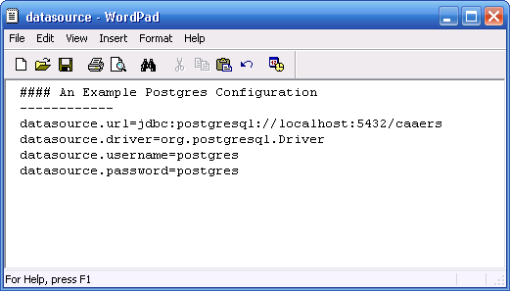

3.0 Configuring Tomcat
- Add the following lines in ${tomcat.dir}/conf/catalina.properties (Every file referenced below will be contained in the ${tomcat.dir}/conf/cabig/ folder)

gov.nih.nci.security.configFile= ${tomcat.dir}/conf/cabig/ApplicationSecurityConfig.xml
java.security.auth.login.config= ${tomcat.dir}/conf/cabig/csm_jaas.config

- To manually install these configuration files:
  - Create a new folder: ${tomcat.dir}/conf/cabig
  - Copy all the files in ${workspace}/projects/core/tools/csm/conf/cabig to ${tomcat.dir}/conf/cabig

    - Open ApplicationSecurityConfig.xml and caaers.hibernate.cfg.xml in a text editor and replace the following:
    - @csm.context.name@ to caaers
    - @tomcat.security.dir@ to ${tomcat.dir}/conf/cabig

- Open the csm_jaas.config and change the following fields:
  - Driver
  - url
  - user
  - psswd

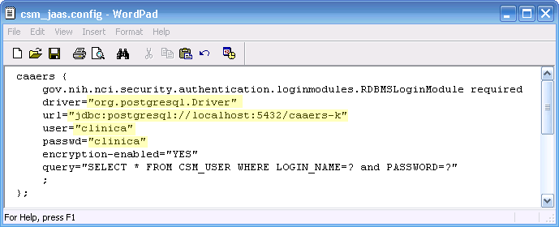

(The above screenshot is an example for Postgres. If you are using Oracle please make the appropriate changes.)

- Open caaers.hibernate.cfg.xml and change the following datasource related properties
  - Username
  - Password
  - URL
  - Driver Class
  - Dialect

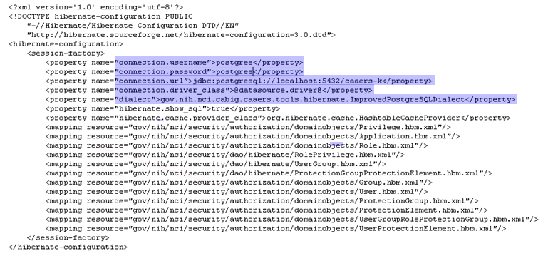
(The above screenshot is an example for Postgres. If you are using Oracle please make the appropriate changes.)

4.0 Enabling SSL
Please refer to the detailed instructions available in http://tomcat.apache.org/tomcat-5.0-doc/ssl-howto.html, to enable SSL.
4.1 Generate a Certificate
- From the command prompt switch to ${tomcat.dir}/conf/cabig, then run the following command
keytool -genkey -alias tomcat -keyalg RSA -keystore caaers_keystore. This will generate a file, “caaers_keystore” in the active directory.

- The keytool command will request the following information, please complete each field
  - Store password
  - Firstname
  - Last name
  - Dns
  - Key password
4.2 Updating the server.xml
- Switch to ${tomcat.dir}/conf, open the server.xml in a text editor
- Search for the lines “<!-- Define a SSL Coyote HTTP/1.1 Connector on port 8443 -->”
- Update the <Connector> element, by un commenting it and specifying the relative directory of the keystore.

<!-- Define a SSL Coyote HTTP/1.1 Connector on port 8443 -->
<Connector className="org.apache.coyote.tomcat5.CoyoteConnector"
port="8443" minProcessors="5" maxProcessors="75"
enableLookups="true" disableUploadTimeout="true"
acceptCount="100" debug="0" scheme="https" secure="true";
clientAuth="false" sslProtocol="TLS"
keystoreFile="conf/cabig/caaers_keystore"/>

5.0 Loading the Database with the Schema/Deploying the caAERS.war
- Copy the caaers.war file from the directory ${caAEERS}
- Start Tomcat, by executing the startup.bat or startup.sh file located in ${tomcat.dir}/bin
- Starting Tomcat will automatically deploy the caaers.war file, this will create a /caeers directory within ${tomcat.dir}/webapps and load the schema into the caaers database
- Open a Browser and navigate to http://localhost:8080/caaers/
- The test login name is “SYSTEM_ADMIN” and password is “system_admin”.

Administration
Once the caAERS application has been installed, login to the application to begin creating users, research staff members, importing studies or participants, or importing a CTC or MedDRA data dictionary and to configure the application.

1.0 Configure caAERS
- ESB queue URL – This is the URL for the enterprise bus service. This value is not going to be applied when the application is restarted. The user can enter the appropriate URL in the text box before moving on to the next field, or they can hit Save.
- LabViewer base URL – This is the base URL for the LabViewer deployment to which the caAERS instance can be linked to. The user can enter the appropriate URL in the text box before moving on to the next field, or they can hit Save.
- Study Calendar base URL – The base URL for the Study Calendar deployment to which the caAERS instance can be linked to can be added in the text field. The user will enter the appropriate URL before moving on to the next field, or they can hit Save
- Show debugging information – This will be used mainly for developers. Some instructive text can be applied to the bottom of each page to help with troubleshooting and features development. Choose Yes or No, it will be No by default. Hit Save.

2.0 Create Investigator
- Investigator Details – Add the following information to the fields in the form.
  - First Name – This is the first name of the Investigator the user wants to create. Required
  - Middle Name – This is the middle name of the Investigator the user wants to create. Optional
  - Last Name – This is the last name of the Investigator the user wants to create. Required
  - NCI Identifier – This is the identifier the Investigator has been assigned by the NCI. Optional
- Associate Sites – Select and enter the following information to complete the creation of an Investigator. If the Investigator is associated with more than one site, the user can add another selection by clicking the green plus sign. If the user needs to remove an associated site, they can hit the red “x” symbol.
  - Site – Drop-down list of all the sites associated with the user’s instance of caAERS. Select the appropriate site name. Required
  - Email Address – This is the email address of the Investigator the user wants to create. Optional.
  - Status – This is the status of the new Investigator. It is a drop-down box with the following values; Active or Inactive. Required
Hit the Save button to commit this new Investigator to the database.

3.0 Create Research Staff
- Add a New Research Staff – Add the following information to the form in order to create new research staff.
  - First Name – This is the first name of the staff member the user wants to add to the application. Required
  - Middle Name – This is the middle name of the staff member the user wants to add to the application. Optional
  - Last Name – This is the last name of the staff member the user wants to add to the application. Required
  - Site – This is the site the staff member will be associated with in the application. The drop-down box will contain a list of acceptable values to choose from. Required.

4.0 Import
- Import Data
  - Import Study/Protocol – By selecting this option, the user is choosing to upload an xML file that has validated against the xML schema containing information on a Study/Protocol or multiple Studies/Protocols. Once the button is clicked, a field will appear that allows the user to upload the xML file. Navigate to the file that needs to be uploaded, select it, and then hit Save or Save & Continue.
  - Import Participant – By selecting this option, the user is choosing to upload an xML file that has validated against the xML schema containing a participant or multiple participants. Once the button is clicked, a field will appear that allows the user to upload the xML file. Navigate to the file that needs to be uploaded, select it, and then hit Save or Save & Continue.
- Review and Submit
  - The information in the xML files will be provided in the user interface for the user to review. During the import process the system will validate the information to see if it already exists or if the schema meets all the requirements. If the user chose to import multiple studies/participants, the list will be separated into the ones successful and the ones that failed.
  - Once the data has been reviewed, the user can submit the information to the database. When the user submits the information, all of the failed imports will be deleted and only the successful imports will be saved.

5.0 Import MedDRA
- Import MedDRA Dictionary – MedDRA versions 9.0, 9.1 are currently supported. The user will need to have a license to use MedDRA as well as the ASCII files with all of the terms ready for upload. The user will enter the file location in the text box and click Import MedDRA.

Contacting Technical Support
Application Support | Please direct any concerns to the Project Manager of the caAERS Development team, Edmond Mulaire.

